**Emergency Information on Mobile**

Software Design Document

By

Putchakarn Jaikon 542115031

Sawatdiporn Kitirot 542115065

Department of Software Engineering

College of Arts, Media and Technology

Chiang Mai University

Project Advisor

__________________________________

**Aj.Chartchai Doungsa-ard**

# Chapter One | Introduction

## 1.1 Objective

The purpose of the software design document (SDD) for Emergency Information on Mobile project is to design the detailed structure of the system accordance with the software requirement specification (SRS). This SDD also making the members in the project team understand the work in the detailed design of the system using class diagram, sequence diagram, entity relationship diagram and user interface design.

## 1.2 Project Scope

Emergency Information on Mobile is composed of 2 parts which are server and mobile part. The server part uses to manage the information of help place. The mobile application part runs on Android OS. Emergency Information on Mobile will provide the necessary information of help places to the user.

## 1.3 Purpose

This software design document consists of progress report I. So the stakeholder of Emergency Information on Mobile can review software design in this progress.

## 1.4 Acronyms and Definitions

**1.4.1 Acronyms**

EIOM Emergency Information on Mobile

SDD Software Design Document

UI User Interface

**1.4.2 Definitions**

|  |  |
| --- | --- |
| Sequence diagram | A sequence diagram in a [Unified Modeling Language](http://en.wikipedia.org/wiki/Unified_Modeling_Language) (UML) is a kind of [interaction diagram](http://en.wikipedia.org/wiki/Interaction_diagram) that shows how processes operate with one another and in what order. It is a construct of a Message Sequence Chart. A sequence diagram shows object interactions arranged in time sequence. It depicts the objects and classes involved in the scenario and the sequence of messages exchanged between the objects needed to carry out the functionality of the scenario. |
| Feature | Transformation of input parameters to output parameters based on a specified algorithm. It describes the functionality of a product in the language of the product. Used for requirements analysis, design, coding, testing or maintenance.[IEEE90] |
| IEEE | Institute for Electrical and Electronics Engineers. Biggest global interest group for engineers of different branches and for computer scientists. [IEEE90] |
| User Interface | The portion of a computer program with which the user interacts, i.e., the interface between a user and a computer program. There are command-line interfaces, menu-driven interfaces, and graphical user interfaces (GUIs). |
| UML | Unified Modeling Languages. Standardized notation for Modeling design descriptions, architectures or scenarios. Not depending on a specific method. Issued and maintained byte object Management Group (OMG).[IEEE90] |

# Chapter Two | System architecture

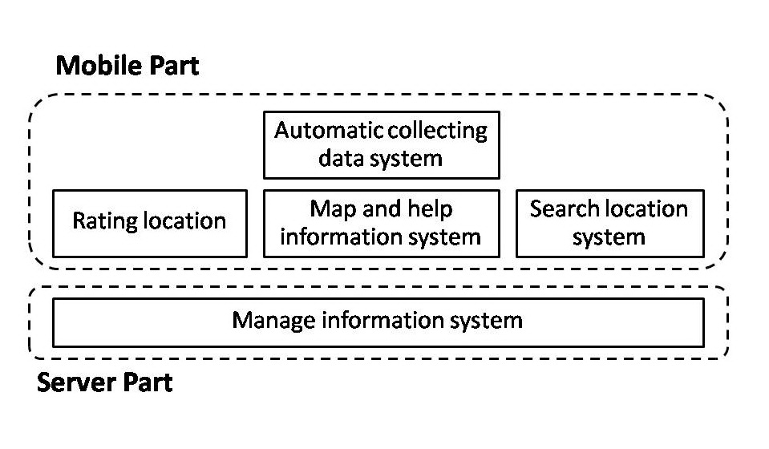

**Figure 1 Architecture overview of Emergency Information on Mobile system**

Figure 1 shows overall of architecture such as map and help information system, search information system and manage information system.

**Mobile Part**

**Feature1: Map and help information system**

* View map and help locations\**/ \*\**
* View information of help locations*/*\*\**
* Make emergency call*/*\*\**

In this feature, the help location will show on the map with their information such as address and phone number. Moreover, the phone number can be called directly on the application.

**Feature2: Search information system**

* Search the contact information by keyword*\*\**
* Search phone number by location*\*\**
* Find nearest help location*/*\*\**

Feature 2 provides search contact information by keyword or name of help location. Furthermore, the application can show the nearest help location in many categories such as a police station, hospital, and garage.

**Feature3: Rating location**

* Rate the help locations*\*\**
* View rating help locations*/*\*\**

In this feature, the user can use the rate function to rate each help location. One user will be count at one for rating each place. The user also updates their rating score anytime they want. The rating location collects the rate and provides the average rate to the user. Furthermore, the rate function will help the user to compose their decision to go among many help locations.

**Feature4: Automatic collecting data system**

* Download data of help location automatically*\*\**
* Set the scope of download data*\*\**

Feature 4 will download data of help location around the user automatically and save into a mobile device. So, the information can be show without internet connection. In addition, the user can set the scope of download data.

**Server part**

**Feature5: Manage information system**

* Add help locations*\*\**
* Edit help locations*\*\**
* Remove help locations*\*\**

Feature 5 furnishes manage information system to admin. The admin can add, edit, or remove the help location.

*\* The offline feature*

*\*\* The online feature*

# Chapter Three | Detailed Design

## 3.1 Class Diagram

### 3.1.1 Server Part

Controller class diagram

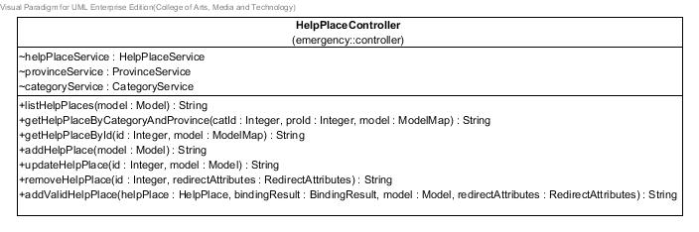

**Figure XX: Controller class diagram**

Service class diagram

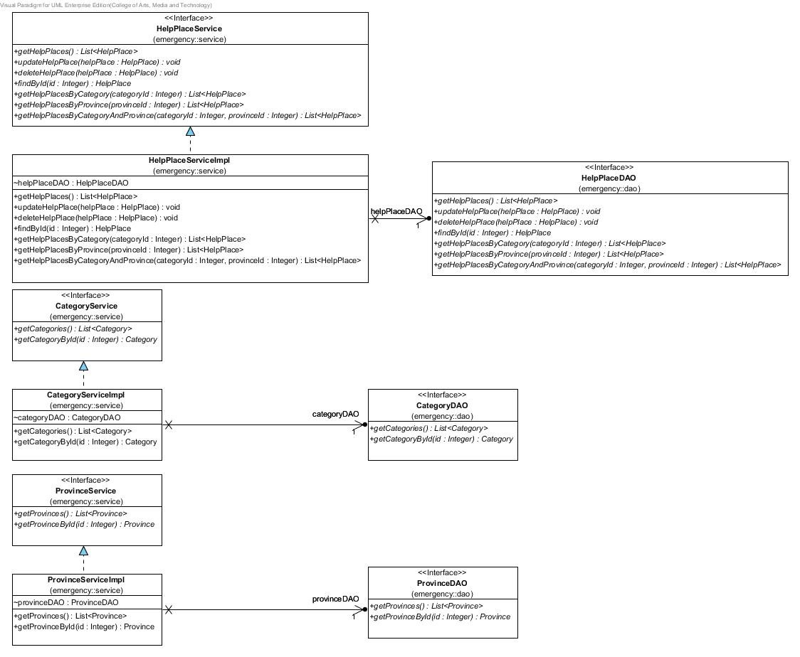

**Figure XX: Service class diagram**

DAO class diagram

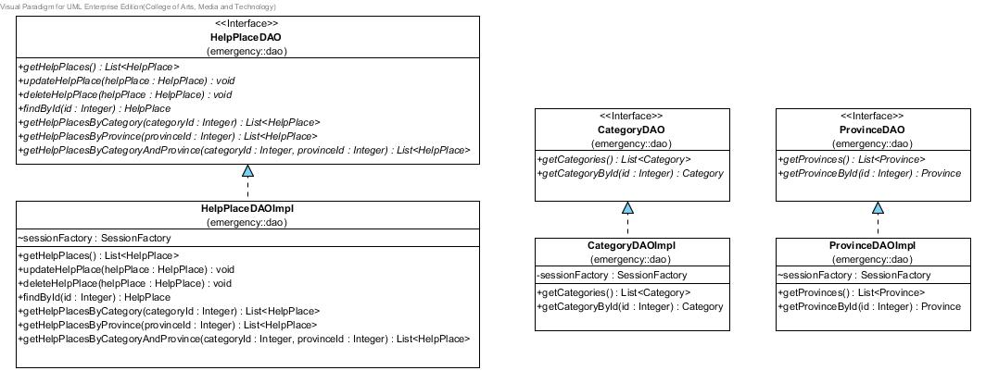

**Figure XX: DAO class diagram**

Entity class diagram

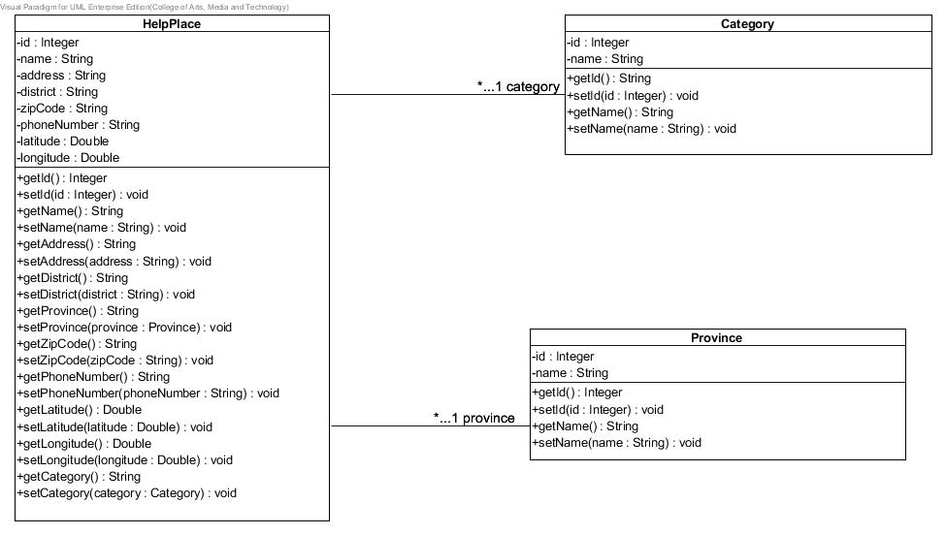

**Figure XX: Entity class diagram**

**3.1.2 Mobile Part**

Emergency Information on Mobile class diagram

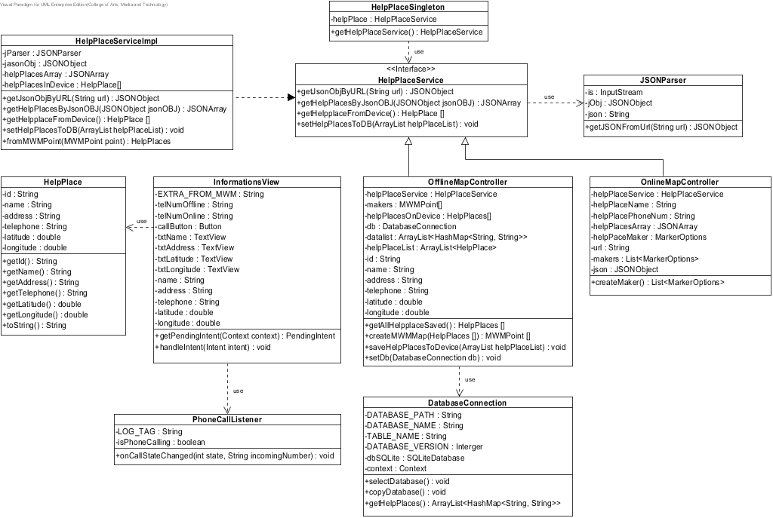

**Figure XX: Emergency Information on Mobile class diagram**

## 3.2 Use case: UC-01 Add help information

Related Class Diagram: CD-01 Related Classes:

Sequence Diagram: SD-01

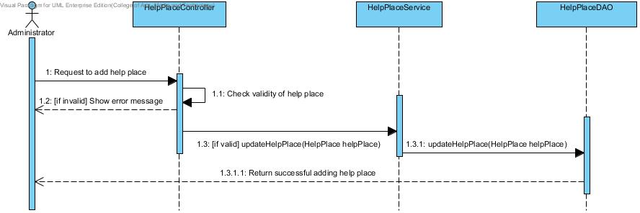

**Figure XX: Add help place information sequence diagram (SD-01)**

**Class name:**

# Chapter Four | User Interface Design

**UI name:** Home Page(UI-01)

Include Requirement: UC-03, UC-05, UC-06, UC-07

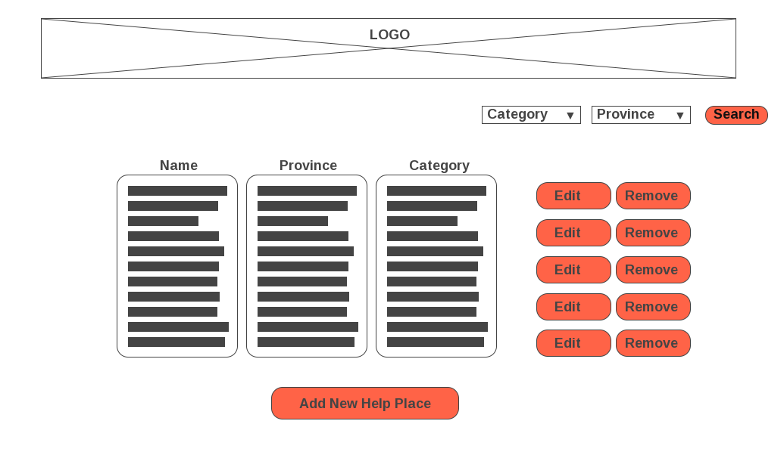

**Figure XX: Home Page (UI-01)**

The home page includes 3 components. The top of page is a logo of web page and “Search” button for searching by selected category and province. The center of page is a list of help places with “Edit” and “Remove” button. The help place will be link with its information page. The last one, the bottom of page is “Add New Help Place” button for adding new help place.

**UI name:** Remove Confirm Dialog(UI-02)

Include Requirement: UC-03

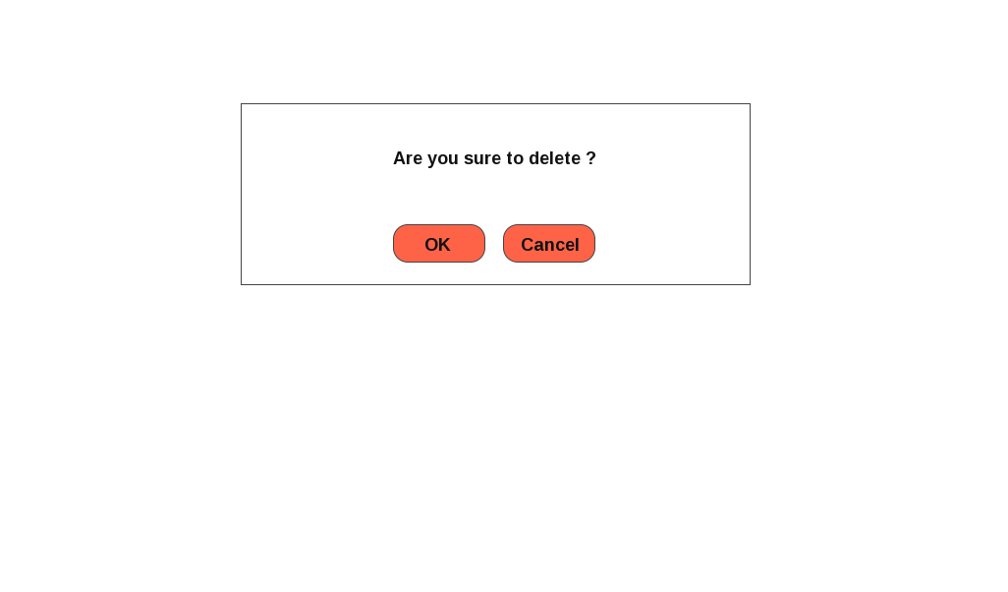

**Figure XX: Remove Confirm Dialog (UI-02)**

The messages dialog shows the confirmation message when administrator try to remove a help place.

**UI name:** SuccessfullyRemove Dialog(UI-03)

Include Requirement: UC-03

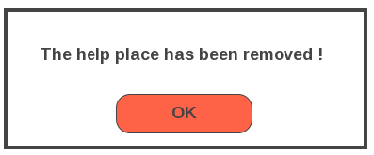

**Figure XX: Remove Confirm Dialog (UI-03)**

The messages dialog shows the message after administrator removes help place successfully.

**UI name:** Update Information Page(UI-04)

Include Requirement: UC-01, UC-02

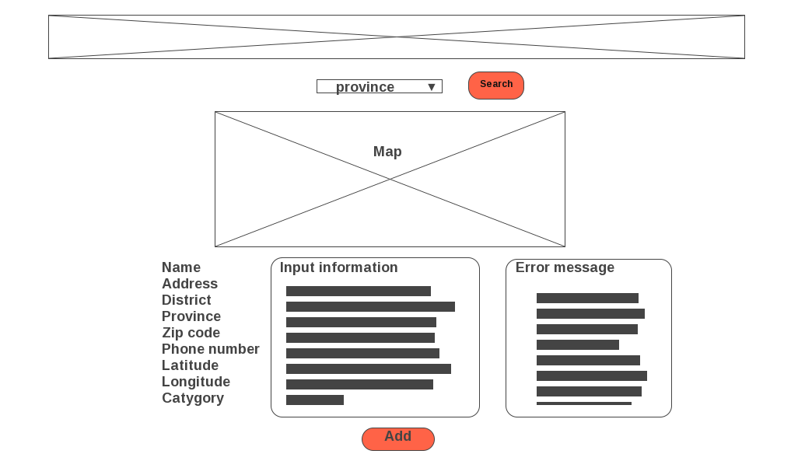

**Figure XX: Edit Information Error Message (UI-04)**

The update information page includes 3 components. The top of page is a logo of web page. The center of page is map and search box which are used for getting latitude and longitude. The last component, the bottom of page is text box for receiving new information from administer with the “Add” button.The error message will be shown when information are not passing the condition.

**UI name:** Successfully Add Dialog(UI-05)

Include Requirement: UC-01, UC-02

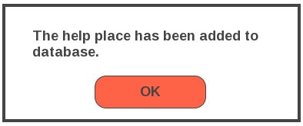

**Figure XX: Remove Confirm Dialog (UI-05)**

The messages dialog shows the message after administrator adds or updates help place successfully.

**UI name:** View Information Page(UI-06)

Include Requirement: UC-04

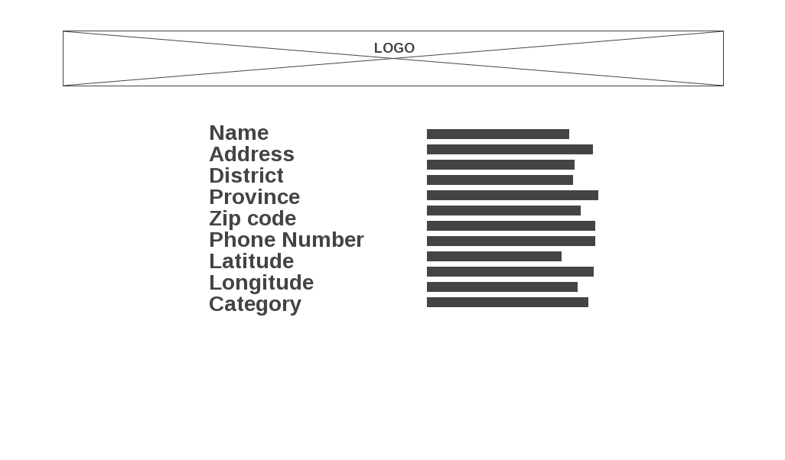

**Figure XX: View Information Page (UI-06)**

The view information page includes 2 components. The top of page is a logo of web page. The center of page shows information of a help place.

**UI name:** Start Page (UI-07)



**Figure XX: Start Page (UI-07)**

The start page shows the online map automatic and buttons for user to switching map.

• Online map

• Offline map

**UI name:** Show Online map (UI-08)

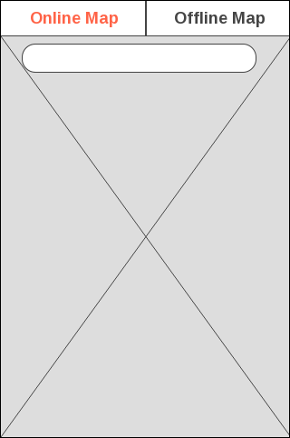

**Figure XX: Show Online map (UI-08)**

The switcher tab online button shows the online map for automatic on Start page. The online map will provide search bar to user search help place on the online map. The button allows users to access the online map.

**UI name:** Connect Offline map (UI-09)



**Figure XX: Connect Offline map (UI-09)**

The switcher tab offline button shows the offline map for Start page. The button allows users to access the offline map.

**UI name:** Show Offline map (UI-10)



**Figure XX: Show Offline map (UI-10)**

MapsWithMe application will show Thailand offline map. The offline map will show automatic when the application lost internet connection.

**UI name:** MapsWithMe application installed (UI-11)

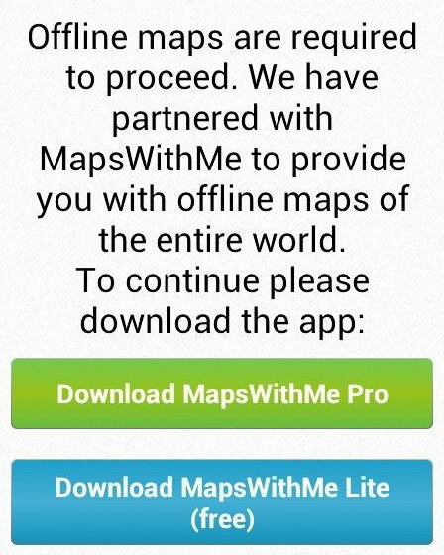

**Figure XX: MapsWithMe application installed (UI-11)**

What will happen if the user call for offline map but MapsWithMe application is not installed? The API library will show simple dialog with gentle offer to download MapsWithMe.

**UI name:** MapsWithMe application (UI-12)

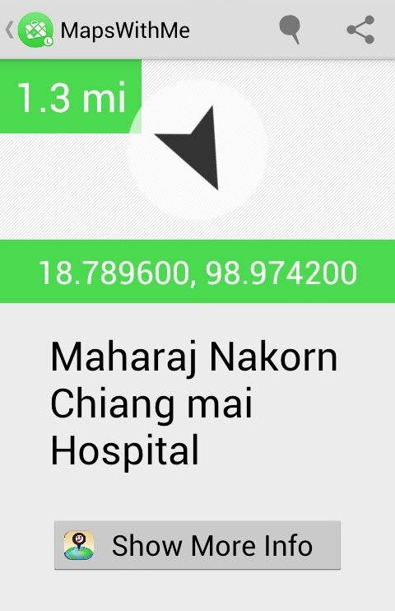

**Figure XX: MapsWithMe application (UI-12)**

MapsWithMe application will start with show offline map. The user selects the help place on offline map to view information. MapsWithMe provides latitude, longitude, name and show more info button.

**UI name:** Show Information Page (UI-13)

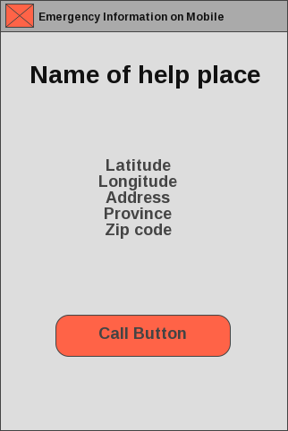

**Figure XX: Show Information Page (UI-13)**

The Show Information page will show latitude, longitude, address, province, zip code and call button. On show information page, the user can call to help place directly from the application.